Comfy™ Spring Loaded Goniometer Elbow Orthosis
(Instructions & Care Plan)

**HCPC Code: E1800 (Rental) **
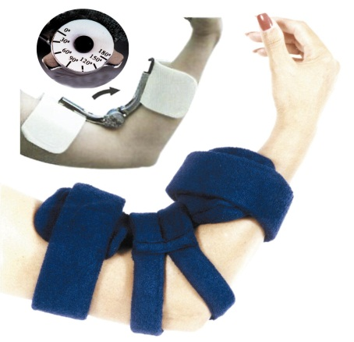
1. After passive range of motion of the elbow, to allow for maximum elbow extension, place Orthosis along the inside flexor surface of the elbow.

2. The Comfy™ Spring Loaded Goniometer Elbow Orthosis can be adjusted to limit the range of flexion or extension of the elbow as desired. Unzip the cover to expose the Goniometer mechanism. Loosen screw with Allen wrench provided (Screw loosens by turning counterclockwise). One Tab limits flexion and one Tab limits the degree of extension. Position one Tab to limit flexion and position the second tab so as to limit the maximum degree of extension allowed. As the patient flexes arm the moderate spring-load will push the extremity to the set degree of extension. The approximate number of degrees can be read off the Goniometer. Note: The point of contact between pin and the tab, most accurately reflects the degree of angulation (not the center of the Tab). Each notch represents 30⁰. When readjusting the range of motion permitted, it is preferred to keep one tab fixed in position (Usually the tab at the 0º mark). Progress in therapy is read off as changes in position of the edge of the tab along the Goniometer marks.

3. The two splint cuffs can be adjusted to the diameter of the patient's arm and forearm. Merely press the Orthosis against a firm edge (e.g. table, countertop or chair edge) while firmly holding and leaning on both ends. Do not remove insert from fabric cover, as all positioning can be done while insert is in the cover. The Comfy™ Spring Loaded Goniometer Elbow Orthosis is easily adjusted and re-adjusted to any desired angle and maintains its shape. To lock the Orthosis in a fixed position: merely place the tabs on both sides of the pin and tighten the screw.

4. Once the desired angulation for the elbow is achieved, re-close the zipper, wrap the straps around the arm and forearm and secure with Velcro. Note the middle, split strap has an opening for the elbow. It is suggested that the therapist maintain a two-finger space under the straps to prevent excessive pressure areas on the patient’s skin.

INTRODUCTION: The Comfy™ Spring Loaded Goniometer Elbow Orthosis is a patient specific product that can be easily fitted and labeled for single patient use upon order of a physician. It should be used only in connection with a care plan and custom fitting instructions by a trained health care professional.

INDICATIONS: The Comfy™ Spring Loaded Goniometer Elbow Orthosis is to be used with patients who present with elbow flexion pattern, arthritic changes and any deformity related to neuromuscular impairment.

RESULTS: The Comfy™ Spring Loaded Goniometer Elbow Orthosis will help increase/maintain elbow extension. It also prevents further deformity, maximizes ROM, and makes maintenance of good hygiene of the involved extremity easier. The terry cloth cover helps absorb moisture and allows for air circulation, thereby helping prevent skin maceration.

CONTRA-INDICATIONS: The Comfy™ Spring Loaded Goniometer Elbow Orthosis should not be used if the patient has any circulatory problems, pressure areas or skin irritations.

FITTING INSTRUCTIONS: The Comfy™ Spring Loaded Goniometer Elbow Orthosis should be applied and fitted only by a trained professional. Fit and shape Orthosis according to patient’s requirements and as indicated in instructions. Check Orthosis fit and place two fingers under strap to ensure strap is not too tight.

WEARING TOLERANCE: Check the Comfy™ Spring Loaded Goniometer Elbow Orthosis at least every two hours until removed, to see if there are any problems such as skin abrasions, redness, blisters, or increased edema (if straps are too tight). With patients who have sensory deficits, the Orthosis should be checked more frequently.

MAINTENANCE OF ORTHOSIS: The Cover of the Comfy™ Spring Loaded Goniometer Elbow Orthosis is designed to be removed for laundering. The fabric cover can be washed by hand or by machine in lukewarm water. Do not use bleach or hot water. Air or tumble dry on cool or warm setting. Wiping both sides with a solution of warm water and detergent or with disinfectant can clean the bend-able white insert.

© 2010 ComfyTM Spring-Loaded Goniometer Elbow Orthosis (Adult & Pediatric)
Lenjoy Medical Engineering, Inc. • Gardena, CA 90249 USA
www.comfysplints.com • T: (800) 582-5332

