**Changing motor & Shaft**

Here are the step by step procedure to replacing the Rotational motors on the “R-375”  lifts.

                Tools you will need

* 5/32 inch Allen wrench
* ¾ Inch Socket Wrench
* ¾ inch Box end Wrench
* Medium Size Snap ring pliers

1.Remove the six through bolts from the main part of the Global Lift see below. It is much easier if you  leave the lift in the anchor . The lift will be split in half  at this point, you want to lay the top half of the lift down on deck.

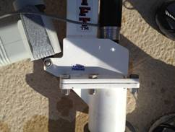

2. Unplug the Rotational Motor from the control box and remove the Allen screws from the underside of the motor See below. (**Discard these 4 Allen screws as they will not be needed.)**

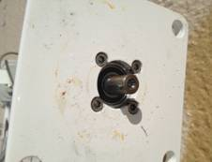

3. Remove Snap Ring from vertical shaft. Its easiest if you leave shaft in anchor while doing this. The lift  outer casing/bearings  slip up over shaft FYI. Remove old shaft with broken motor shaft.

    Remove broken shaft from top of main spindle. This may require drilling and tapping the shaft to pull it. Once removed, place back in anchor hole  Slide on the outer casing/bearings. Replace the snap ring to hold in place.

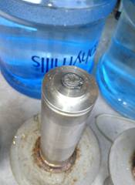

4. Re-attach the upper beam using the four back bolts(do not tighten at this time) to hold the two plates together. Reinstall the new rotational motor into the base. Line the key on the rotational motor with the key in the shaft until it drops in. Line up the hole on the motor collar with the bolt hole by manually turning the lift. Tighten the ¾ inch screws on the base. Plug in rotational motor into control box. Finished.

