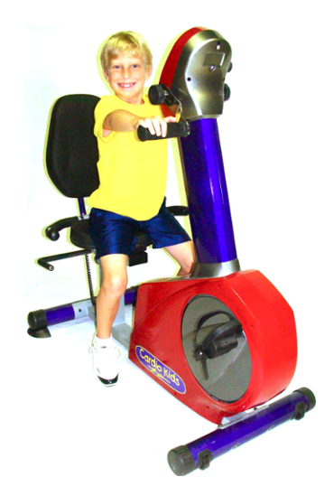
Cardio Kids 664 Elementary Total Body Kidz Cycle
OWNERʼS MANUAL

PARTS LIST
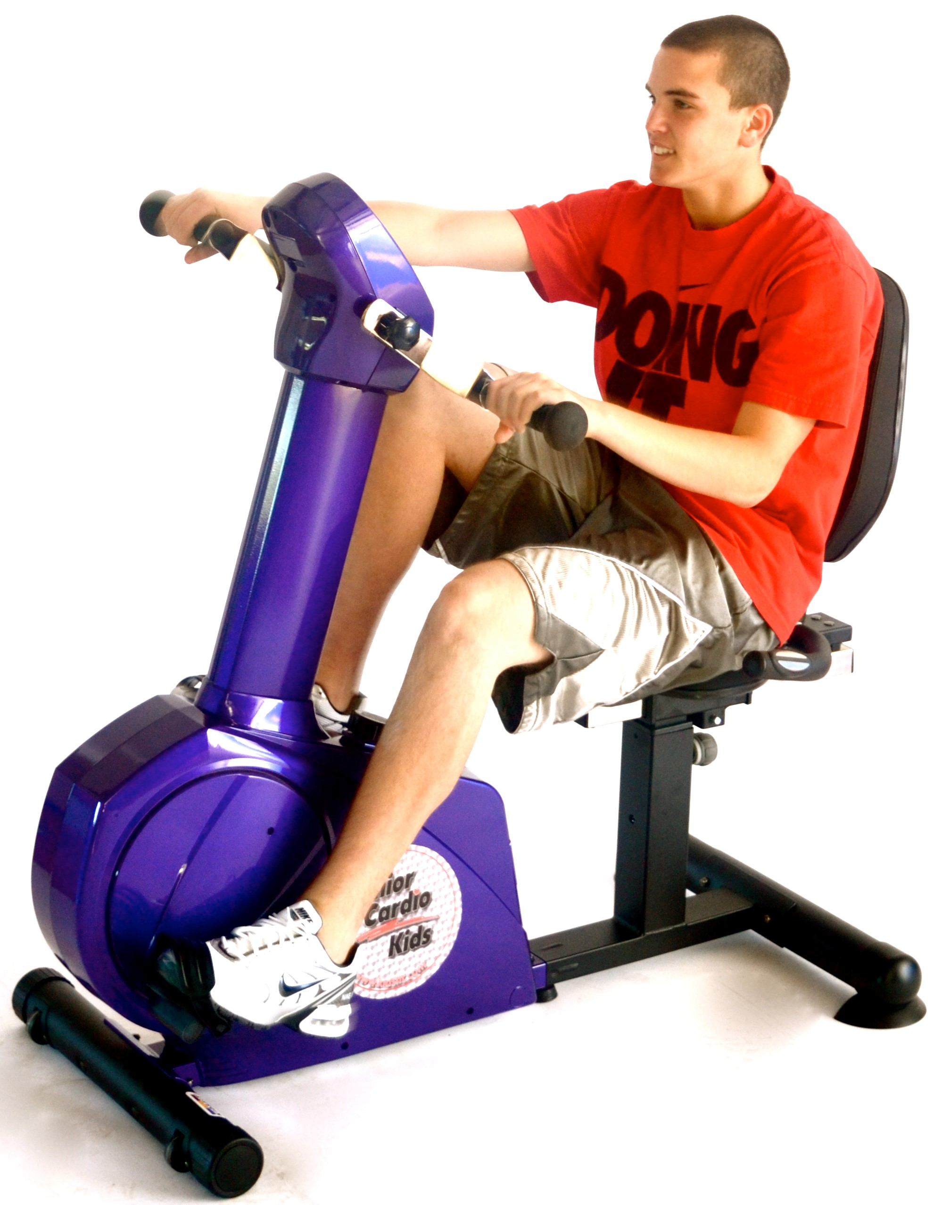
Leveler Feet
Computer
Large Rubber Grip Handle
Adjustment Knob
Foot Pedals
Wheel

INSTRUCTIONS
A.
- Make sure the machine is in a neutral position as seen in picture A.
- Firmly grab the handle grips to the left and right sides of the machine.
- Gently position both feet on the foot pedals before beginning any movement.

INSTRUCTIONS
B.
- Slowly begin to propel the arms forward in a circular rotation. Once the user has become comfortable with this motion, increase speed
- Slowly begin to propel the legs forward, increasing speed as the user becomes accustom to the motion.

INSTRUCTIONS
6. Instructor should have each user:
C.
- Before exiting the machine come to a full stop as seen in picture C.
- While using the hand grips for support, slowly step off of the machine.

